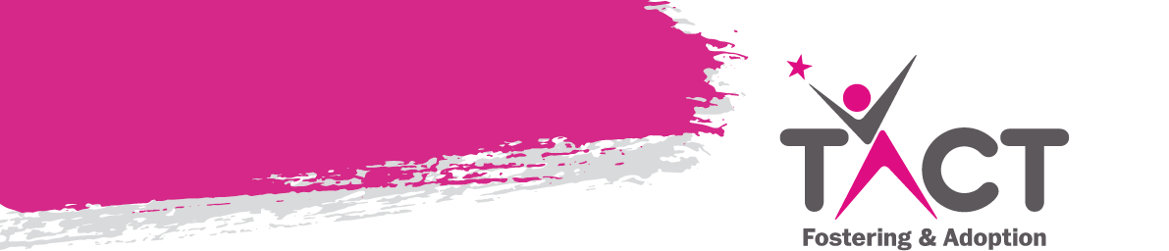

WEEKLY NEWSLETTER

**“One's destination is never a place, but a new way of seeing things”-** Henry Miller

**OOH ROTA 2024**

|  |  |  |
| --- | --- | --- |
| **Date** | **Name** | **Contact Number** |
| Monday 29th April | Chloe Hegarty | 07793 580412 |
| Tuesday 30th April | Hannah | 07872 817 172 |
| Wednesday 1st May | Anju | 07912 308 943 |
| Thursday 2nd May | Diane | 07760 628 653 |
| Friday 3rd May | Mohamed | 07713 261216 |
| Saturday 4th May | Mohamed | 07713 261216 |
| Sunday 5th May | Mohamed | 07713 261216 |
| Monday 6th May – bank holiday | Mohamed | 07713 261216 |

**Tactconnect Email address:**

As you are aware plans are in place to remove the tactconnect email address and replace with your own personal one. A date has not yet been confirmed as to when the changeover will take place, therefore please continue to use your tactconnect email address until the date has been finalised and until you receive further information from us. If you have not already sent admin your personal email address please can you do this by the end of this week. **[birminghamadmin@tactcare.org.uk](mailto:birminghamadmin@tactcare.org.uk)**

**MANDATORY TRAINING FOR**

**ALL FOSTER CARERS**

Please be aware that all the mandatory training must be completed as soon as possible by **ALL CARERS**, not just the main carer – we are currently doing an audit of all training that is outstanding as this is looked at by Ofsted when we have inspections and will impact upon the result they give us if not all carers have taken the courses.

Here is the link to the courses below:-

<https://tact.fosteringtraining.com/index>

**](https://tact.fosteringtraining.com/index)**

**Carers transferring to TACT with foster children in placement.**

It is a generally a misconception that LA’s will remove children if a carer transfers agencies. It definitely will not happen if the transfer from another IFA. If the carers are coming from an LA pressure is sometimes applied.

It the LA did hint or suggest this could happen (as we know they sometimes do) then carers will need to be a strong advocate and work with the child’s IRO to stand firm on what is in the child’s best interests. We have experienced this on number of occasions, and it has worked.

You could also share a copy of the Fostering Network Transfer Protocol – we share this with prospective transferring carers that enquire with TACT, and it serves to give them the knowledge and reassurance they need that there is structure and process that should be followed if they have a child in their care.

Please encourage carers you know in this situation who want to transfer to TACT to reach out to us. We will talk them through the process and give them the knowledge & support they need to make an informed decision.

**Spaces are still available – please call admin to book your place. Alternatively email -** **[birminghamadmin@tactcare.org.uk](mailto:birminghamadmin@tactcare.org.uk)**

**Course: Delegated Authority**

**Date: 9th May 2024**

**Time:** 10.00a.m. – 12.00 Noon (12.00 – 1.00pm Q&A)

**Provider:** *Social Care Hub/Steve Stanier*

**Venue:** Microsoft Teams

This course gives participants a comprehensive overview of the legislative context of delegated authority and allows them to explore delegated authority from different perspectives. The training also gives an overview of delegated authority practice issues.

**Course: Criminal Exploitation/ County Lines**

**Date: 15th May 2024**

**Time:** 10.00a.m. – 12.00 Noon (12.00 – 1.00pm Q&A)

**Provider:** *Social Care Hub/Andy Limbert*

**Venue:** Microsoft Teams

This program aims to assist participants to understand how the "County Lines" element of gang culture has developed into what is now being called an "epidemic

of child criminal exploitation". We will examine how the issue overlaps with grooming, online safety and child sexual exploitation. The course explores how

gangs use social media as a recruitment tool to present the lifestyle as easy access to money, friendship and a glamorous lifestyle. They also then use it to control new members. We also examine the real impact on the individual, their families and broader society.

We are partnering with **Louise Bomber’s TouchBase** to offer two interesting days of training which will give insight into what attachment and trauma difficulties in a child might look like in an education setting, and what strategies you might be able to use to support them to engage in learning.  This will also help you to be able to advocate for the right support for your child in their PEPs.

This training is open to all SSWs and carers, but with limited spaces – so book your place ASAP!

**Inside I’m Hurting (Day 1) – Friday 10th May 2024 09:30 – 4pm (online)**

**Supporting the pupil who has experienced significant relational traumas and losses.**

This day of training is suitable for a wide range of professionals and parents/carers who are interested in understanding how to settle a troubled pupil to learn within the education context. It is intended to inspire those who attend, enabling them to realise that they can all contribute and make a difference whatever their role or responsibility. The day will also encourage alternative practices in schools by using an attachment aware and trauma informed framework to understand behaviour as communication.

**What About Me? (Day 2) – Friday 27th September 2024 09:30 – 4pm (online)**

**What might attachment support look like during a school day?**

This day is intended for education staff and parents/carers who have completed Day 1. This day is much more interactive than Day 1 and therefore a smaller audience is best. Delegates will get more out of the day if they read back over their notes from Day 1 and come willing to contribute. Day 2 assumes knowledge of the principles and practices covered in Day 1. Throughout the day participants will have opportunity to reflect upon how to extend attachment aware and trauma informed approaches in everyday practices within school.

To book onto any session, please email [**EducationService@tactcare.org.uk**](mailto:%20EducationService@tactcare.org.uk)

*Holidays/ Activities*

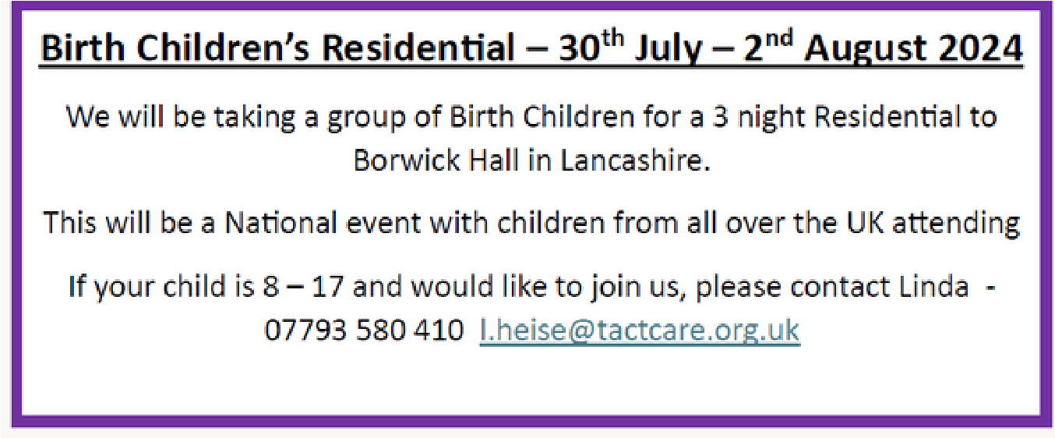

# A person smiling for a picture Description automatically generatedKaren Treisman Training

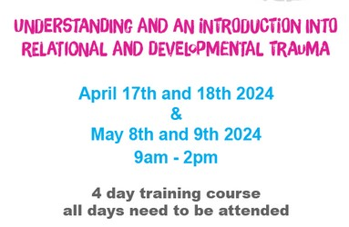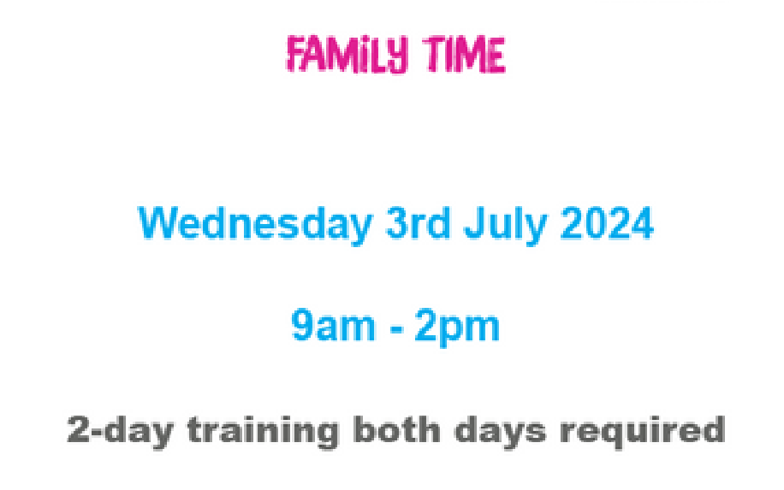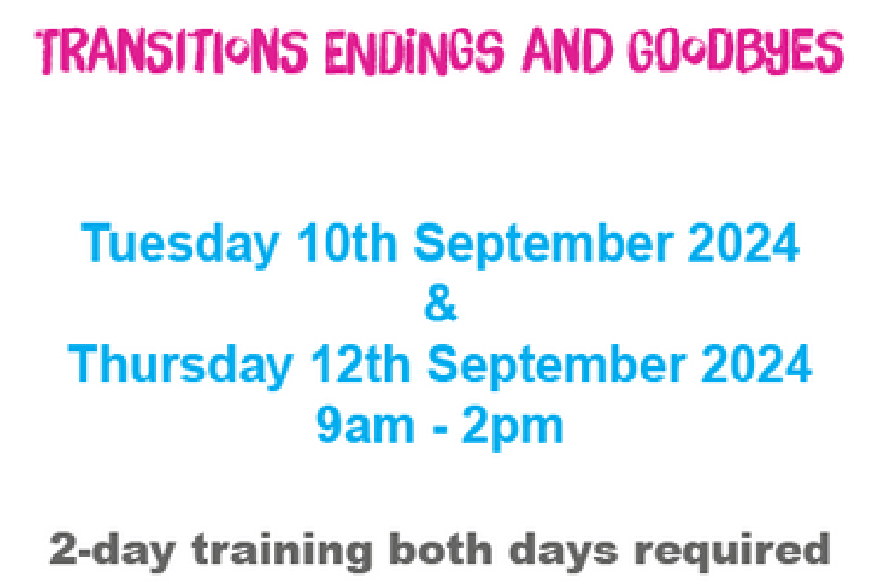

Please email us to book any of these courses –

[**birminghamadmin@tactcare.org.uk**](mailto:birminghamadmin@tactcare.org.uk)



***SESSION DATES***

**England and Wales: 15th August GCSE**

**For the TEAMS link to attend please email:** [**EducationService@tactcare.org.uk**](mailto:EducationService@tactcare.org.uk)

***RESULTS DAY SUPPORT***

As we did last year, when the time comes for results day, we will be offering a phone line again for any young person or carers who want to discuss results received and next steps. We understand it can be tricky when results are not what expected, or plans need to be altered and are here to support. We will send a reminder nearer the time and will be available all day on 07502 325 104. Results days are listed below for your diaries:

**England and Wales: A Level Results Day 15th August**

**England and Wales: GCSE Results Day 22nd August**

As we did last year, when the time comes for results day, we will be offering a phone line again for any young person or carers who want to discuss results received and next steps. We understand it can be tricky when results are not what expected, or plans need to be altered and are here to support. We will send a reminder nearer the time and will be available all day on 07502 325 104.