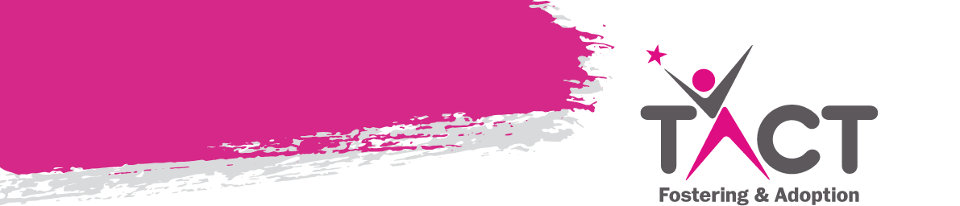**Weekly Bulletin**

**“One's destination is never a place, but a new way of seeing things”-** Henry Miller

**OOH ROTA 2024**

|  |  |  |
| --- | --- | --- |
| **Date** | **Name** | **Contact Number** |
| Monday 22nd April | Chloe | 07793 580412 |
| Tuesday 23rd April | Hannah | 07872 817 172 |
| Wednesday24th April | Sajeeda | 07591 385 767 |
| Thursday 25th April | Sorrel | 07717 557 893 |
| Friday 26th April | Caroline | 07921 973 321 |
| Saturday 27th April | Caroline | 07921 973 321 |
| Sunday 28th April | Caroline | 07921 973 321 |

**Thank you**

We would like to say a BIG THANK YOU to all our regular dedicated carers who, always make the time to attend circle of friends group.  I do hope you found the presentation useful on the 17/04/2024.

Thank you to those who always make the time to send their apologies, we appreciate you doing this.

In addition, we would like to show appreciation to Sam and Alex for their commitment for staying over to assist with Recruitment event. Your Kindness and dedication to others and the service don’t go unnoticed.

The Numbers for Circle of Friends Group remain low, each time this incur a financial loss for the service and the organisation as a whole. Whilst we want to support those who regularly attend,  we will now need to consider the regularity of these sessions and re focus on those frequent attendees.  This decision has been considered to reflect year on year losses

Kind Regards

Diane Green

**Tactconnect Email address:**

As you are aware plans are in place to remove the tactconnect email address and replace with your own personal one. A date has not yet been confirmed as to when the changeover will take place, therefore please continue to use your tactconnect email address until the date has been finalised and until you receive further information from us. If you have not already sent admin your personal email address please can you do this by the end of this week.

**Carers transferring to TACT with foster children in placement.**

It is a generally a misconception that LA’s will remove children if a carer transfers agencies. It definitely will not happen if the transfer from another IFA. If the carers are coming from an LA pressure is sometimes applied.

It the LA did hint or suggest this could happen (as we know they sometimes do) then carers will need to be a strong advocate and work with the child’s IRO to stand firm on what is in the child’s best interests. We have experienced this on number of occasions, and it has worked.

You could also share a copy of the Fostering Network Transfer Protocol – we share this with prospective transferring carers that enquire with TACT, and it serves to give them the knowledge and reassurance they need that there is structure and process that should be followed if they have a child in their care.

Please encourage carers you know in this situation who want to transfer to TACT to reach out to us. We will talk them through the process and give them the knowledge & support they need to make an informed decision.

**Spaces are still available – please call admin to book your place. Alternatively email -** [**birminghamadmin@tactcare.org.uk**](mailto:birminghamadmin@tactcare.org.uk)

**Course: What’s Going On In The Teenage Brain**

**Date: 23**.04.2024

**Time:** 10.00a.m. – 12.00 Noon (12.00 – 1.00pm Q&A)

**Provider:** Heather Hengstenberg

**Venue:** Microsoft Teams

During this training the trainee will gain a greater awareness of how a teenager’s brain changes neurologically during puberty and the effects that this has on them in terms of: • Their emotional state, focussing in particular on sudden difficulties with empathy

• Their behaviour state, focusing on why they begin to take more risks

• Their general mental health, focusing on; addictions, depression, self-harm

• Their sleeping patterns, why a regular sleep pattern is essential throughout this training particular attention will be placed on improving understanding of the teenage brain, from their perspective, and the positive steps that can be implemented to enable them to achieve their full potential.

We are partnering with **Louise Bomber’s TouchBase** to offer two interesting days of training which will give insight into what attachment and trauma difficulties in a child might look like in an education setting, and what strategies you might be able to use to support them to engage in learning.  This will also help you to be able to advocate for the right support for your child in their PEPs.

This training is open to all SSWs and carers, but with limited spaces – so book your place ASAP!

**Inside I’m Hurting (Day 1) – Friday 10th May 2024 09:30 – 4pm (online)**

**Supporting the pupil who has experienced significant relational traumas and losses.**

This day of training is suitable for a wide range of professionals and parents/carers who are interested in understanding how to settle a troubled pupil to learn within the education context. It is intended to inspire those who attend, enabling them to realise that they can all contribute and make a difference whatever their role or responsibility. The day will also encourage alternative practices in schools by using an attachment aware and trauma informed framework to understand behaviour as communication.

**What About Me? (Day 2) – Friday 27th September 2024 09:30 – 4pm (online)**

**What might attachment support look like during a school day?**

This day is intended for education staff and parents/carers who have completed Day 1. This day is much more interactive than Day 1 and therefore a smaller audience is best. Delegates will get more out of the day if they read back over their notes from Day 1 and come willing to contribute. Day 2 assumes knowledge of the principles and practices covered in Day 1. Throughout the day participants will have opportunity to reflect upon how to extend attachment aware and trauma informed approaches in everyday practices within school.

To book onto any session, please email [**EducationService@tactcare.org.uk**](mailto:%20EducationService@tactcare.org.uk)

*Holidays/ Activities*

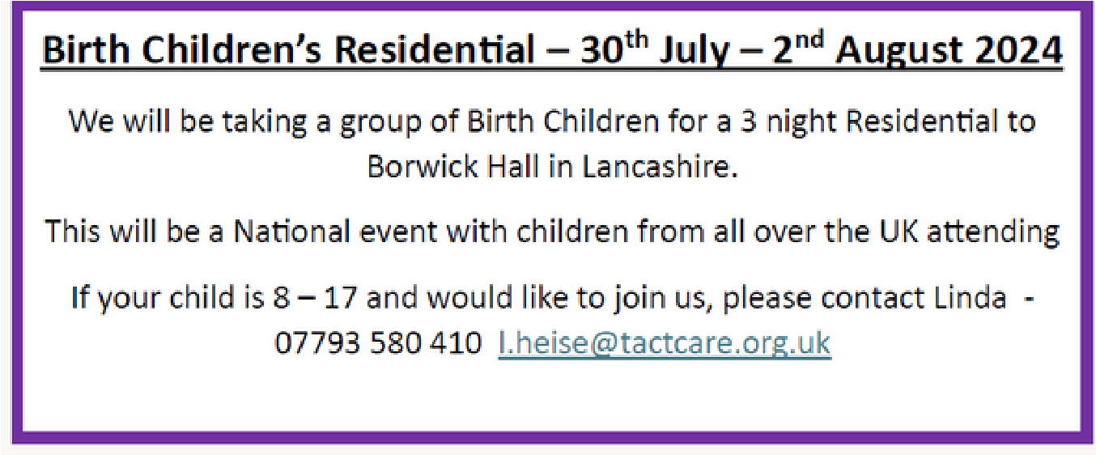

# A person smiling for a picture Description automatically generatedKaren Treisman Training

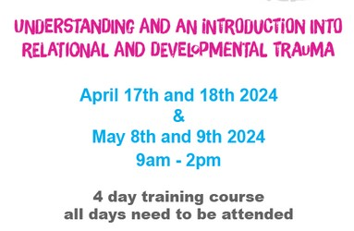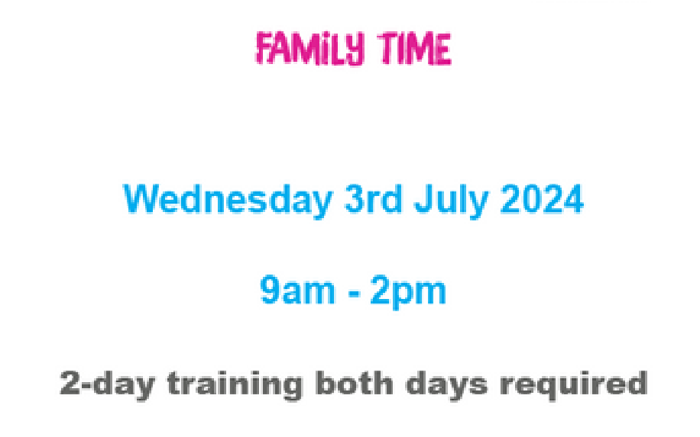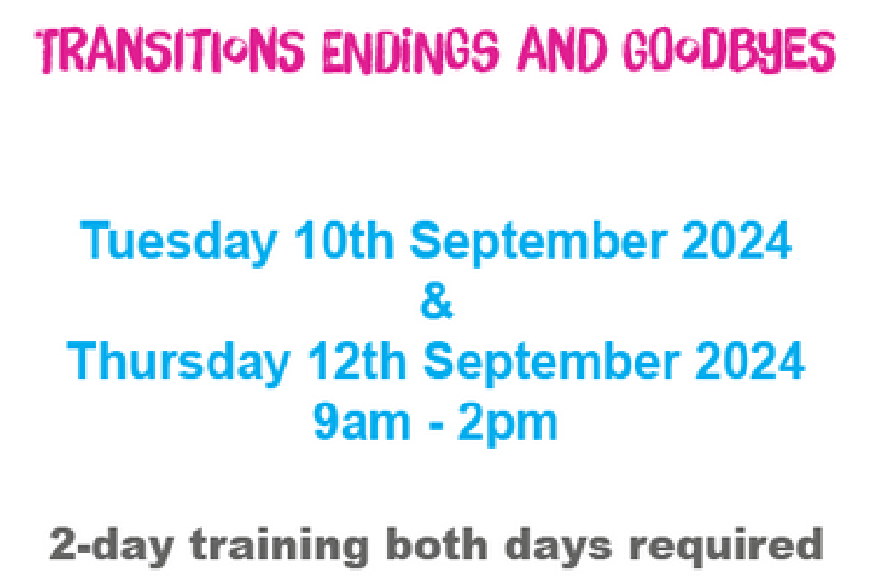



***SESSION DATES***

**England and Wales: 15th August GCSE**

**For the TEAMS link to attend please email:** [**EducationService@tactcare.org.uk**](mailto:EducationService@tactcare.org.uk)

***RESULTS DAY SUPPORT***

As we did last year, when the time comes for results day, we will be offering a phone line again for any young person or carers who want to discuss results received and next steps. We understand it can be tricky when results are not what expected, or plans need to be altered and are here to support. We will send a reminder nearer the time and will be available all day on 07502 325 104. Results days are listed below for your diaries:

**England and Wales: A Level Results Day 15th August**

**England and Wales: GCSE Results Day 22nd August**

As we did last year, when the time comes for results day, we will be offering a phone line again for any young person or carers who want to discuss results received and next steps. We understand it can be tricky when results are not what expected, or plans need to be altered and are here to support. We will send a reminder nearer the time and will be available all day on 07502 325 104.